THANK YOU
I just wanted to send a note of thanks to all of you
It has been a great experience at NAFAO and
Without the memberships continued support
It would not be the organization is has become
I have attached a photograph of the prosecco glasses
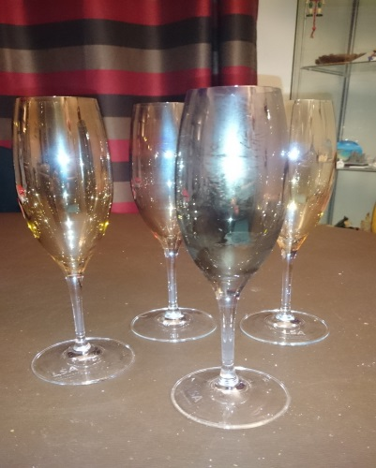
I bought with the voucher you gave me as a leaving gift.
Any of you who know me well enough will not be surprised it was prosecco glasses I chose.
I have fond memories of my involvement with NAFAO and wish Robbie and Bridgette every success for the future.
Beverley

